Performance Testing
Date | 29 September 2026
Team ID | SWTID-2026-4039
Project Name | AI WeatherWise
Maximum Marks | 5 Marks

Performance Testing
Performance testing evaluates how the AI WeatherWise system behaves under expected and peak load conditions.
Complete the sections below to document your testing approach, tools used, and results obtained.
Step 1: Testing Overview
Field | Details
Testing Tool Used | JMeter / Postman
Type of Testing | Load Testing, Stress Testing, Spike Testing
Target Module / API | Weather Forecast API / AI Weather Prediction API
Test Environment | Local / Cloud
Test Date | 29 September 2026

Step 2: Test Scenarios
S.No | Test Scenario / Description | No. of Virtual Users | Duration (sec) | Expected Outcome
1 | Multiple users request current weather information simultaneously | 10 | 60 | Weather data should be displayed without errors
2 | Users request weather forecast for different locations | 20 | 60 | Forecast should be returned within acceptable response time
3 | Multiple users access AI weather prediction feature | 30 | 60 | AI prediction should respond correctly without system failure
4 | Sudden increase in users accessing weather services | 50 | 60 | System should handle increased load with minimal errors

Step 3: Performance Test Results
S.No | Metric | Target Value | Actual Value | Status (Pass / Fail) | Remarks
1 | Response Time (Avg) | < 2 seconds | To be filled | To be filled | Record average response time from the testing tool
2 | Response Time (Max) | < 5 seconds | To be filled | To be filled | Record maximum response time
3 | Throughput (Req/sec) | As high as possible | To be filled | To be filled | Record requests processed per second
4 | Error Rate | < 1% | To be filled | To be filled | Record percentage of failed requests
5 | CPU Utilization | < 80% | To be filled | To be filled | Record CPU usage during testing
6 | Memory Utilization | < 80% | To be filled | To be filled | Record memory usage during testing

Step 4: Observations & Analysis
The performance testing of the AI WeatherWise system is intended to evaluate the response time, throughput, error rate, CPU utilization, and memory utilization under different user loads. The actual observations and analysis should be completed after executing the performance tests using the selected testing tool.
Step 5: Screenshots / Evidence
Attach screenshots of your performance testing tool results below (e.g., JMeter report, Postman results, response-time graphs, throughput results, CPU utilization, and memory utilization)

SCREENSHOT 1 :
start the program using testing tools
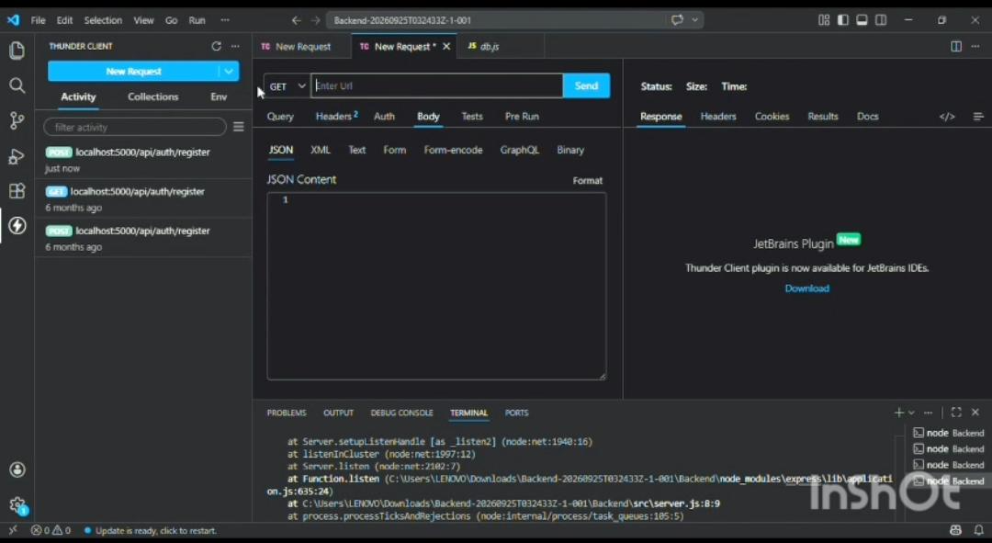
SCREENSHOTS 2:
End of the program
